Annex P: Agriculture in the Project Landscape and potential Project interventions

Breakdown of number of men and women engaged in agriculture
The most comparable data across the seven main divisional secretariats (with regards to agriculture related livelihoods) is available in the 2013/14 economic census of small scale farmers. These are described as farmers who either have more than 40 perches of land or sell most of their harvest, the farming activities of small scale farmers is further defined as supposed to occur within less than 20 acres of land. Reports have been prepared for each district, therefore the data below is collected from the Anuradhapura, Mannar and Vavuniya districts.

Table 1. Primary and Secondary Farmers disaggregated along gender 1Department of Census and Statistics, (2014) 2 (Department of Census and Statistics, 2014c) 3 (Department of Census and Statistics, 2014b)
TL | District | Division | Primary Farmers |  | Secondary Farmers |  | Total
TL | District | Division | Male | Female | Male | Female | Male | Female
1 | Anuradhapura¹ | Kekirawa¹ | 9458¹ | 1932¹ | 58¹ | 10¹ | 9516¹ | 1942¹
1 | Anuradhapura¹ | Thirappane¹ | 5534¹ | 1145¹ | 23¹ | 6¹ | 5557¹ | 1151¹
1 | Anuradhapura¹ | Mihintale¹ | 5210¹ | 1102¹ | 0¹ | 1¹ | 5210¹ | 1103¹
2 | Vavuniya² | Vengalacheddikulam² | 2980² | 721² | 2² | 0² | 2982² | 721²
3 | Musali³ | Mannar³ | 1564³ | 131³ | 46³ | -³ | 1610³ | 131³
3 | Manthai West³ | Mannar³ | 1935³ | 370³ | 26³ | 13³ | 1961³ | 383³
3 | Nanaddan³ | Mannar³ | 2342³ | 318³ | 22³ | 12³ | 2364³ | 330³

Table 2. Farming community engaged in agricultural activities 1Department of Census and Statistics, (2014) 2 (Department of Census and Statistics, 2014c) 3 (Department of Census and Statistics, 2014b)
TL | District | Division | Rice |  | Tea |  | Rubber |  | Coconut |  | Other permanent Crops
TL | District | Division | Men | Women | Men | Women | Men | Women | Men | Women | Men | Women
1¹ | Anuradhapura¹ | Kekirawa¹ | 5928¹ | 859¹ | 20¹ | 1¹ | 2¹ | 1¹ | 8689¹ | 1763¹ | 8763¹ | 1763¹
1¹ | Anuradhapura¹ | Thirappane¹ | 2815¹ | 453¹ | 10¹ | 1¹ | -¹ | -¹ | 4438¹ | 925¹ | 4295¹ | 913¹
1¹ | Anuradhapura¹ | Mihintale¹ | 2170¹ | 320¹ | 2¹ | 1¹ | -¹ | -¹ | 4507¹ | 917¹ | 4593¹ | 983¹
2² | Vavuniya² | Vengalacheddikulam² | 1330 | 200 | 0 | 0 | 9 | 0 | 1783 | 497 | 1898 | 476
3 | Musali³ | Mannar³ | 1237 | 104 |  |  |  |  | 709 | 68 | 424 | 51
3 | Manthai West³ | Mannar³ | 1047 | 136 |  |  |  |  | 1114 | 177 | 751 | 125
3 | Nanaddan³ | Mannar³ | 1484 | 111 |  |  |  |  | 2126 | 272 | 1910 | 241

Table 3. Other Farming related activities disaggregated along gender 1Department of Census and Statistics, (2014) 2 (Department of Census and Statistics, 2014c) 3 (Department of Census and Statistics, 2014b)
TL | District | Division | Other Seasonal Crops |  | Engaged in keeping cattle |  | Engaged in keeping Goats |  | Engaged in keeping Pigs |  | Engaged in keeping Chickens |  | Other animals
TL | District | Division | Male | Female | Male | Female | Male | Female | Male | Female | Male | Female | Male | Female
1 | Anuradhapura¹ | Kekirawa¹ | 6441¹ | 1113¹ | 640¹ | 57¹ | 73¹ | 8¹ | 6¹ | -¹ | 723¹ | 93¹
1 | Anuradhapura¹ | Thirappane¹ | 3204¹ | 561¹ | 363¹ | 33¹ | 45¹ | 3¹ | 19¹ | 2¹ | 266¹ | 29¹
1 | Anuradhapura¹ | Mihintale¹ | 3139¹ | 566¹ | 422¹ | 47¹ | 47¹ | 7¹ | 5¹ | 2¹ | 449¹ | 62¹
2 | Vavuniya² | Vengalacheddikulam² |  |  | 853² | 163² | 226² | 52² | 3² | 0² | 1043² | 267²
3 | Musali³ | Mannar³ | 286³ | 39³ | 409³ | 30³ | 112³ | 12³ | 9³ | -³ | 789³ | 63³ | 11³ | 3³
3 | Manthai West³ | Mannar³ | 440³ | 107³ | 351³ | 42³ | 41³ | 5³ | 2³ | -³ | 856³ | 150³ | 4³ | -³
3 | Nanaddan³ | Mannar³ | 713³ | 115³ | 1231³ | 100³ | 123³ | 26³ | 3³ | -³ | 1703³ | 226³ | 33³ | 2³

Apart from the above figures, the Statistical Handbooks which are produced by the divisional secretariats provide the following details.

Table 4. Employment details provided by the divisional secretariats in their respective Statistical Handbooks 1.(Kekirawa Divisional Secretariat, 2016) 2. (Mihintale Divisional Secretariat, 2017) 3.(Secretariat, 2016) 4. (Vengalacheddikulam Divisional Secretariat, 2017) 5. (Musali Divisional Secretariat, 2017) 6. (Nanaddan Divisional Secretariat, 2016) 7.(Manthai West Divisional Secretariat, 2017)
Year | Name of District | DS division | Agriculture/farming
Year | Name of District | DS division | Male | Female | Total
2017 | Anuradhapura | Kekirawa |  |  | 8264¹
2016 | Anuradhapura | Mihintale |  |  | 3012²
2016 | Anuradhapura | Thirappane |  |  | 7634³
2018 | Vavuniya | Vengalacheddikulam |  |  | 3567⁴
2016 | Mannar | Musali |  |  | 3268⁵
2016 | Mannar | Nanaddan |  |  | 2,969⁶
2017 | Mannar | Manthai West | 16⁷ | 2⁷

With regards to the profile of vegetable crops that are grown, in the Anuradhapura district the vegetable crop consists of the following at the included percentages

Table 5. Crop Profile grown in the Anuradhapura district (Export Development Board, 2013)
Luffa | 10% | Ash Pumpkin | 29%
Okra | 12% | Red Pumpkin | 27%
Brinjals | 15%

(The Statistical Handbooks only has sparse information regarding other crops grown in each Divisional Secretariat).

Switching from farming paddy to vegetables is a practice which farmers in Anuradhapura seem to follow when the monsoons failed to provide adequate water to engage in paddy cultivation. However in a recent article in the Daily Mirror Newspaper (Embogama, 2018) it is clear that such adaptive measures leave them at risk of overproduction and the inability to reach markets where prices were more lucrative forces them to incur a loss. For example, pumpkin farmers in the Monaragala district described how pumpkins from elsewhere were brought in large quantities to their markets which further reduced the market price of this vegetable (Mirror Citizen, 2018). It appears that dumping the harvest is the only measure that is available to farmers who face such predicaments, however Sri Lanka’s largest supermarket operator Cargills Food City did attempt to help the farmers in selected villages by providing special deals where with the assistance of the Nawagaththegama District Secretariat and Puttalam District Samurdhi Directorate they purchased the surplus crop and offered 500g of pumpkin free of charge to consumers who shopped for more than Rs. 750 at Cargills Food City. Lack of options available to store Surplus production is a problem which vegetable farmers consistently face as will be discussed below.

Marketing arrangements for agricultural produce
Fernando, (2006; cited in Wasala et al., 2014) describes a simplified supply chain of fruits and vegetables (pertinent to Sri Lanka) as follows:
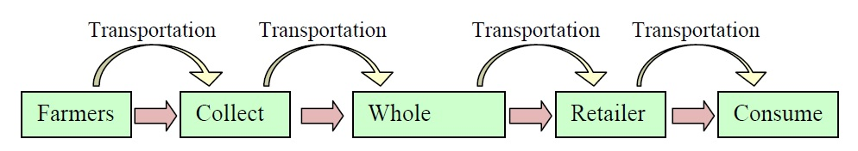

Figure 1. Supply Chain of fruits and vegetables Fernando, (2006; cited in Wasala et al., 2014)

Vidanapathirana (2008; cited in Sandika, 2011) describes the existing market channels for vegetables in Sri Lanka in a more elaborate manner as shown below.

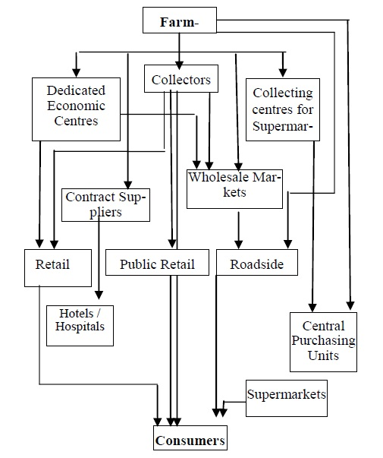

Figure 2. Market channels for vegetables in Sri Lanka Vidanapathirana (2008; cited in Sandika, 2011)

A third diagram demonstrating the distribution of fruits and vegetables is provided by Dharmasena and Sarananda, (no date).
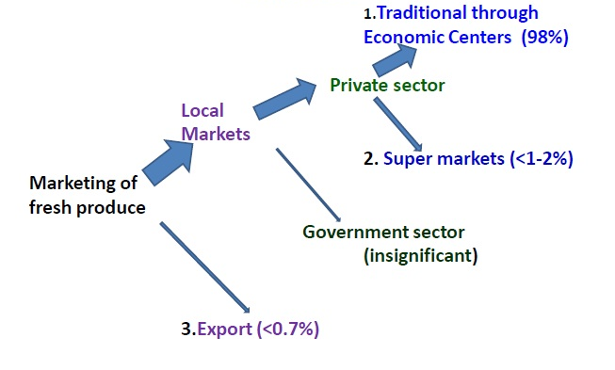

Figure 3. Market channels for vegetables (Dharmasena and Sarananda, no date)
The second and third schematics are useful when trying to understand the impact of middle men and their influence on the political economy of the agricultural sector. An inquiry into the role of middlemen and their impact on vegetable marketing channels was made by Sandika, (2011) by considering the relationships between the Retail price, producer Price and the Market Margins of a selection number of vegetables over a period of 17 years (1991-2008). The author of this study concluded that it is unfair to criticize the middlemen by asserting that they are exploiting the consumers and producers because they are playing a major role in the domestic vegetable marketing channel”. However Dharmasena and Sarananda, (no date) mentions that there is no proper pricing mechanism at the economic centres (see Figure 3) where middlemen and retailers meet. The process is described as a gathering of wholesalers who subsequently decide on a price. Although Sandika, (2011) mentions that the price quoted by the middlemen is low during times of excess and high during times low supply, Dharmasena and Sarananda, (no date) mentions that during times of excess there is also high postharvest losses due to a lack of storage facilities. However Ranathilaka and Kuntoro, (2014) provides a contradictory observation and mentions that “merchants in every channel of vegetable market show monopolist’s characteristics of the market function under the open economic system”.

Among the major economic centres that are located in the island, the one located in Dambulla is said to handle 4000 tonnes of produce per day (Dharmasena and Sarananda, no date). The reduced bargaining power of farmers, the cartel behavior of middlemen and the unnecessary middlemen involvement (which disrupts markets) are identified by Ranathilaka and Kuntoro, (2014) as issues observed in the Dambulla Economic Centre. Other conditions and features which further empower middlemen and reduce the bargaining power of farmers are small marketable volumes, the perishability of the products, lack of adequate production/marketing credit/transport facilities/information/organization capacities of farmers. Improvements in research and development and capacity development which would lead to better modes of transport, handling, storage, packaging, pre-harvest treatments (e.g. fungicide), sanitation, and capacity building focused on maintaining recognized food standards and value addition activities are requirements in this sector which could assist in reducing postharvest losses (Ranathilaka and Kuntoro, 2014; Wasala et al., 2014; Vidanapathirana et al., 2018)

It is worth contrasting market chain activities occurring in economic centres with that which occurs with respect to supermarkets. In these chains, the farmer’s produce reaches cold storage facilities in collection centres and are then transported in cold trucks to supermarket outlets. It is important to note that while post-harvest losses are less compared to that of economic centres and the expected income of farmers could be as higher than conventional market chains (by as much as 20%), the handling prices are much higher (Dharmasena and Sarananda, no date; Vidanapathirana et al., 2018).

Apart from the less than ideal activities of the middlemen, the activities of farmers themselves affect the fruit and vegetable markets as well. For example improper usage of pesticides, fertilizer and fruit ripening agents, and unsuccessful storage and transport activities which lead to post-harvest losses are among such activities (Vidanapathirana et al., 2018).

Potential to introduce Modified Agricultural Practices to the Trial Landscapes and Good Agricultural Practices

There was a specific request to make a judgment about the potential to introduce modified agricultural practices in the Trial Landscapes based on what was heard during the visits made to them. It seems that prior to introducing some of the communities engaged in agriculture to various premium markets, water scarcity is something which would need to be addressed in certain areas. However it must be kept in mind that the availability of water is quite variable across the same project areas (eg. the old Bihidiya farm had more access to water due to its proximity to the new Bihidiya farm). Therefore it would be best to compile this information with Sandun, Annie and myself present. It must also be kept in mind that in areas where water was not a concern or at least less of a concern, it does appear to be possible to introduce modified agricultural practices provided introductions are made to premium markets.

With regards to the ability to implement Good Agricultural Practices, Rajapakse et al., (2017) conducted an assessment into how farmers access information with regards to GAP practices, and these are.
- Verbally communicating with the agricultural extension officer. The government extension officers (Counselors for Agri-business (CAB offices) and Agricultural Instructors (AIs) were the commonly named source of information. A high level of trust is said to exist between the CAP officers (government extension officers). The authors suggest that this is probably due to the fact that CAB officers are expected to visit export farmers regularly. However some farmers did mention instances when the government extension officers had provided information of low quality. Another criticism is the fact that some farmers had with formal sources of informations was the fact that advice on spacing between plants is considered to be too high and could result in a reduction in the crops.
- Calling the number 1920 crop advisory service which is provided by the Department of Agriculture
- Print copies of the Gap standards
- Online sources were also used by some farmers. Rajapakse et al., (2017) quotes a farmer who accessed the internet to find the information he needed because the book provided by the Department of Agriculture (DOA) did not provide the information they sought. Some respondents also pointed out that they did not know which websites would provide high quality information. Furthermore, some of the suggestions on the internet were not applicable or were too costly for them to implement (eg. usage of greenhouses). Some of the online sources that were accessed include:
  - The Goviya facebook page
  - The Krushi havula webpage
- TV programmes such as govi bimata arunalu however a criticism which this programme received was the advice provided was on a wide range of geographic contexts so activities which were done in other parts of the island might not be possible elsewhere.
- Traditional practices/previous experiences and informal sources such as family members and neighbouring farmers. However some farmers have had negative experiences using such sources.
- Other studies mentioned in Rajapakse et al., (2017) also mention television and radio broadcast programs although such programmes have high accessibility, the information and knowledge provided might be too general. However trained extension agents are described as an effective method of imparting knowledge to farmers.
Sambasivan et al. (2010 cited in (Rajapakse et al., 2017)) highlights the following obstacles in the way of effective communication of best practices (however the applicability of these aspects in the Sri Lankan context had not been established by Rajapakse et al., (2017).
- Non-literacy
- Non numeracy
- Lack of digital operation skills
- Financial constraints affecting technology ownership
- Socio-cultural and empowerment issues including gender, employment and social status.

A recommendation which Rajapakse et al., (2017)makes is that there is a lack of feedback from the farmer with regards to the quality of service provided by the formal sources of information. The authors also recommended putting more information and advice provided by the government institutions onto online platforms in an easy to access manner.

The Division of Agribusiness counseling (DOAgbiz) which is also known as the Agro Enterprise Development and Information Service which is under the Extension & Training Centre of the Department of Agriculture is the main focal point of agribusiness and agro entrepreneur development activities in the DOA. Sri Lanka also does appear to receive aid from bodies such as the European Union and organizations such as the Japan International Cooperation Agency (JICA) And the International Fund for Agricultural Development (IFAD). Furthermore the Asian Productivity Organisation (APO) in Tokyo Japan sponsored and organized a three day e-learning course on GAP practices for greater market access(Extension and Training Division: Department of Agriculture - Sri Lanka, no date a; Daily FT, 2015; ECONOMY NEXT, 2017; Programme Management and Department, 2017; Daily News, 2018). It is interesting to note that the Extension and Training Division of the Department of Agriculture –Sri Lanka has an online list of GAP Certified farmers which is available at (Extension and Training Division: Department of Agriculture - Sri Lanka, no date b)

The organic enterprise in Sri Lanka

In a 2008 study that was conducted by the Sri Lanka Nature Forum the total area of Sri Lanka under organic agriculture was considered to be 25335 ha and the certified organic lands was 19,191 ha. The major market channel for organic produce in Sri Lanka is the export market namely focused on USA, Japan and Australia with the markets in Middle East being an up and coming one. The major domestic markets are those which are located in urban areas. There are currently 38 (See table 22) certified food exporters in Sri Lanka who focus on spices, fruits, coconut based products, tea and herbal extracts. It is important to note that the term organic has been misused in Sri Lanka, and should formally be used based on compliance with an accepted and recognized set of standards (Vidanapathirana and Wijesooriya, 2014).

Table 22. Certified Organic Food Exporters (Vidanapathirana and Wijesooriya, 2014)
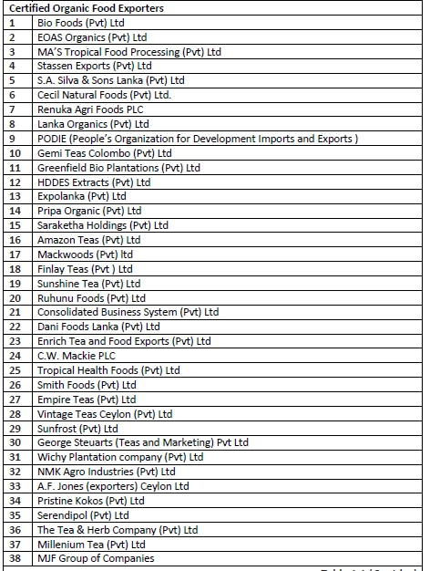

Institutional Framework of the Organic Enterprise
With regards to the export markets, most developed countries have established standards which should be met with documentary evidence which is checked at customs. These standards are based on guidelines that have been established by institutions such as the International Federation of Organic Agriculture Movements (IFOAM) and Codex Alimentarius. International Certification Bodies (which could either be private or government affiliated organizations set up their own standards which are compliant with the standards of individual countries or of regional unions such as the European Union. Therefore the ICB performs the services of a third party evaluator which guarantees compliance an d issues a verifiable certificate, such an arrangement is more acceptable compared to first party certification (the grower provides the assurance) or second party certification (an organization which the grower belongs to provides an assurance). Groups of small scale farmers could apply for group certification where an Internal Control system is used which promises to ensure that the group will take on the responsibility of ensuring that the production processes and the standards are maintained amongst the members. The National Organic Control Unit (NOCU) is in the process of being established under the purview of the Sri Lanka Export Development Board as an “independent national body to control the export/import of all organic agricultural products”. It is expected that the laboratories that would contribute to the enterprise of (accreditation of organic products by the Sri Lanka Accreditation Board (SLAP) would also need to be registered with NOCU. The “NOCU will also serve the purpose of obtaining the 3rd country registration in the EU market which would facilitate the low cost of organic certification and avoid tariff barriers to enter into the EU market”. The Export Development Act No. 40 of 1979 provided the basis for the regulations which would facilitate the implementation of these requirements. Parliament approval has also been received for these regulations which were published in the government gazette. Therefore the Export Development Board would be considered to be the Organic Control Body of Sri Lanka for cultivation, production, processing, manufacturing and sales (which includes export and import of organic products). The NOCU therefore would be entrusted with monitoring and controlling export and import of organic products, obtain 3rd country registration in the EU markets which would reduce the barriers to enter the EU markets, provide certification to farmer clusters at an affordable price, increase the income of farmers by 30-100%, increase export earnings, reduce the import of agrochemicals and provide other services to help the organic enterprise in Sri Lanka and generate government policies focused on this sector. South Korea has shown Interest in establishing organic markets in Sri Lanka by establishing the Korea Program on International Agriculture (KOPIA) in Kandy in 2011 which aims to share technology pertaining to organic agriculture and establishing an organic agricultural model village. Furthermore it also has played a role in attracting the interest the Korean company Hyosung ONB which has invested in a BOI approved organic fertilizer company. Apart from the government agencies, ICBs, local and international companies engaged in the trade of organic products, another important local institution is the Good Market which plays a role in providing a platform for Sri Lankans organic producers to trade their products. The good market played a key role towards the establishment of the Participatory Guarantee System (PGS) which bases its standards on those recognized by IFOAM and engages consumers and producers to volunteer their time to participate in monitoring visits. Such standards allow small scale organic farmers who cannot afford the more expensive certification processes to take part in the organic markets locally, furthermore such standards could encourage such farmers to follow more established and recognized standards. The Sri Lanka Standards Institute has also introduced organic standards pertaining to organic farming and the institute is in the process of obtaining accreditation of the Sri Lanka Accreditation Board (SLAB) (Vidanapathirana and Wijesooriya, 2014; Export Development Board, 2017; Attygalle, 2018).

Vidanapathirana and Wijesooriya, (2014) tabulated the stakeholders which were taken into consideration during the study along with the perceived role they play.

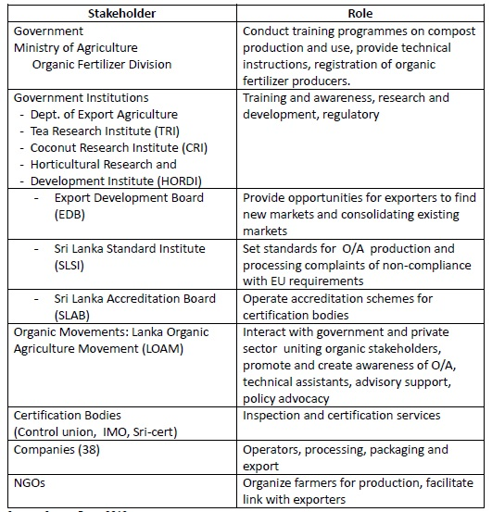
Table 23. Role of Different Stakeholders (Vidanapathirana and Wijesooriya, 2014)

Pros and Cons of the Organic enterprise in Sri Lanka
A study done to explore the perception of organic rice farming which was done in six divisional secretariats in the Kurunegala District (Nayakarathna et al., 2013)found that farmers were largely aware of the basics of organic practices, although there was a lack of knowledge in the technical aspects of these farming practices. They were however unhappy about the time lag between the application of organic practices and the expected response from the crops. The perceptions on how organic products are better for one’s health and reduced costs have interested some to switch to gaining compliance from tidy organic practices .

Requirements of the enterprise
Ms. Charitha Abeyratne, Director, Branding and Marketing, Saaraketha Organics points out that accessibility to quality organic seeds, lack of postharvest infrastructure to reduce postharvest losses, lack of support structures to carefully handle organic produce and the need to have reduced freight rates hinder the export of organic products from Sri Lanka (Attygalle, 2018). There also appears to be a need to increase awareness about organic paddy farming methods which is an aspect that the Rice Research and Development Institute of Sri Lanka could provide assistance for. Other forms of support which the state could provide are policies concerning premium prices and subsidies for organic inputs (Nayakarathna et al., 2013).

Vidanapathirana and Wijesooriya, (2014) mentions the following as major constraints faced by the exporters and farmers
- Insufficient raw materials for export
- High cost of certification
- Lack of research and development
- High cost of production
- Lengthy conversion period
- High cost of labour
- Lack of awareness
- Lack of marketing avenues
- Lack of acceptable inputs
- The exporters mentioned specifically that more support is needed from the government for farmers, processors and exporters and more research and development on value addition.
- Other recommendations by Vidanapathirana and Wijesooriya, (2014) include
  - Producers (especially smallholders) should be provided support with compliance related activities, and introduction to markets
  - Improving the research and development for value added products, and facilitate the supply of disease resistant seeds and substitutes for agrochemicals.
  - Facilitate farmer linkages and promote Sri Lankan organic products.
  - Policy measures which would incentivize the local production of organic inputs.
  - Establish the National Organic Control Authority
  - Conduct promotions to popularize organic produce in local markets

In order to remedy these impacts the authors suggest that the government should incest in quality research to develop value added products, develop training programmes for producers, promote certification programmes, develop national policies for organic food production, promote local organic produce in international fairs, provide subsidies for organic growers, create platforms so that organic exporters could collectively meet supply and demand and get NOCA to obtain third country registration.

Production of Paddy/Rice
Rodrigo, (2016) describes the findings of a study conducted by the Institute of Policy Studies of Sri Lanka where the researches wanted to explore whether a reduction can be observed in the yields of organic paddy farmers and non-organic paddy farmers. The study did not find a statistical difference between the yields of both types of farming practices, however it was not clear whether the use of higher yielding varieties and usage of astrology (which are practices the study did not intend to study the impact of) influenced the yields. There were also discrepancies between the perception organic farmers had with regards to a lower requirements of seed paddy and the actual difference between the seed paddy requirements of both groups of farmers (in other words no difference was observed). It was also observed that close to 20% of farmers who identified themselves as organic farmers did use chemical fertilisers albeit at less than average amounts. In terms of usage of labour, it appears that organic practitioners use more shared labour methods compared to non-organic farmers, furthermore, the organic paddy farmers spent more on machinery due to the inability to use conventional machinery on such farms (mainly due to the morphology of the plants), furthermore, due to organic paddy lands being muddier compared to conventional paddy lands, the time it takes to prepare the land with a tractor is also higher which increases the cost of land preparation. The study also found that the organic farmers received a higher farm gate price compared to the non-organic farmers. Rodrigo, (2016) points out that it should be kept in mind that the study was conducted in 2015 when the fertilizer subsidy was in effect which significantly reduced the cost of engaging in non-organic farming while the organic farmers had to incur many transaction costs such as transportation and the procurement of organic fertilizer. Many organic paddy farmers were less inclined to sell their harvest even when offered a higher price, focus group discussions revealed that a main reason for not engaging in commercial production was the fact that the opportunity cost of finding markets was high.

Vidanapathirana and Wijesooriya, (2014) mentions the benefits provided by the exporting companies to the farmers as follows:
- Above market rate of prices for their crops
- Benefits through fair trade premiums (if applicable
- Training
- Extension services
- Organic fertilizer
- Enhanced knowledge on market potential
- Technical advice
- Apart from the above farmers linked to exporters received the following benefits
  - Collective bargaining power stemming from the membership in farmer organisations
  - Health insurance for growers and workers
  - Support during the conversion period by linking them to other buyers
  - Tangible benefits such as receiving agricultural equipment
  - Support to develop infrastructural facilities
Vidanapathirana and Wijesooriya, (2014) also provides the following SWOT Analysis with regards to the Organic export market.

Table 24. Strengths, Weakness, Opportunities and Threats in the Organic Food Export Market
(Vidanapathirana and Wijesooriya, 2014)
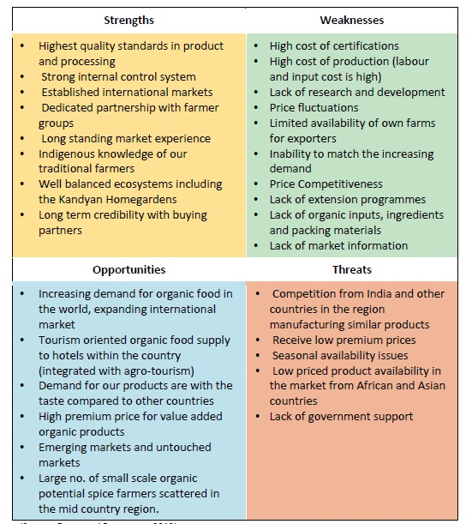

When considering the threats to paddy farming, it is important to keep in mind that seed production for the subsequent year is somewhat determined by the harvest of the current year. This is because in Sri Lanka, paddy seed is produced by contracted local outgrowers and not sourced from other countries (Zappacosta and Hollema, 2017), therefore a failed season has impacts that spill over to the next season. Improving the resilience of farmers to Climate Change is of utmost importance for Sri Lanka’s food security.

Chronic Kidney Disease of Unknown Etiology
Chronic Kidney Disease of Unknown Etiology (Cod) is a health concern which has recorded over 20,000 deaths in Sri Lanka over the past decade (Nanayakkara et al., 2017). The North Central province is among the provinces which show a high incidence of this disease Cod. Although one particular causative agent has not been established for this disease, it is speculated that the incidence of the disease has an association with agriculture. Therefore studies recommend that safe water consumption and prudent farming practices with responsible usage of crop inputs be popularised among farmers (Rajapakse, Shivanthan and Selvarajah, 2016; Kumaresan, Seneviratne and Selvarajah, 2017). Sustainable agricultural practices promoted in this project are aimed at reducing the usage of agricultural inputs used by the farmers in the project area. Therefore, even though reducing the risk of CKDu borne by the beneficiaries is not a primary focus of the project, a reduction is expected as a windfall benefits of this project.

Production and Marketing of Traditional Rice Varieties
Sri Lanka produced close to 1000 traditional varieties of rice in the early 1960s, however with the increase in popularity of “H” series of rice varieties which were introduced in the 1950s the country is said to have lost many of these varieties. Rambukwella and Priyankara, (2016) points out that there is a growing demand for traditional varieties of rice, especially among consumers who are suffering from Non Communicable Diseases. However the only 0.4% of the total cultivated extent of land is dedicated to traditional varieties. When considering production levels, it should be kept in mind that the yield of traditional varieties is less than the modern varieties and the time it takes to harvest the crop that’s sown is also greater, therefore it would be difficult to meet the country’s needs by totally depending on traditional varieties. The most popular varieties of traditional rice among farmers are Suwanee (which was also the most popular among the consumers), Kālu Hematic, MA-Wee, Rather, Madathawalu, Hetadha vee, Murungakayan, Kuruluthuda, Pachchaperumal and Kahawanu, Kuru Vee, Gonabaru, Dhikvee, Rath-el. However traditional varieties of rice could be twice the cost of new varieties of rice. Rambukwella and Priyankara, (2016) Describes these varieties and nutritional and medicinal properties of them (including studies which were conducted to further explore these properties.

Which many perceived to be an artificially inflated cost, however it must be noted that incentives are required to peak the farmer’s interest with regards to growing these varieties. State institutions such as the Central Provincial Economic Development Centre have commenced projects to improve the enterprise of traditional rice cultivation. The Department of Agriculture (through its regional offices) is also conducting awareness programmes to publicise the benefits of consuming traditional varieties of rice while also conducting educational programmes on cultivating traditional varieties of rice and establishing partnerships between likeminded farmers. The DOA in partnership with the Vocational Training Authority (VTA) has also established a National Vocational Qualification on traditional farming practices aimed at getting the younger generation interested in this practice. The Thisara Yaya project conducted by the Agriculture Ministry also plans to promote the cultivation of traditional varieties of rice.

Rambukwella and Priyankara, (2016) state that extension services provided to these farmers were less than ideal, and that nearly 30% of the sampled farmers had not received significant knowledge on how to engage in this practice. Furthermore among the main complaints these farmers had with regards to this enterprise, poor extension services, lower yield and the scarcity of genuine seeds were cited frequently. Apart from remedying these shortcomings, the author also suggests that more research needs to be done on the medicinal qualities of these traditional varieties and stringent regulations need to be placed on the stakeholders of this enterprise. With regards to the medicinal and nutrition levels, it is important to note that Rambukwella and Priyankara, (2016)’s study on consumers suggested that 48% of the consumers mainly considered the nutrition and taste of the traditional varieties, while 35% of the consumers considered the organic value and 13% considered it’s suitability to prevent certain diseases.

References
Attygalle, R. (2018) ‘Getting to the roots of going organic in SL’, Sunday Times, 14 October. Available at: https://www.pressreader.com/sri-lanka/sunday-times-sri-lanka/20181014/283240213969589.

Daily FT (2015) ‘The APO e-learning course on Good Agricultural Practice kicks off in Colombo’,

Daily FT2. Available at: http://www.ft.lk/article/482813/The-APO-e-learning-course-on-Good-Agricultural-Practice-kicks-off-in-Colombo.

Daily News (2018) ‘JICA extends support for enhancing good agricultural practices’, Daily News. Available at: http://www.dailynews.lk/2018/10/18/business/165844/jica-extends-support-enhancing-good-agricultural-practices.

Department of Census and Statistics (2014a) Economic Census 2013/14 - Sri Lanka, Data on Agricultural Activities, Details about Small Scale Farmers in the Anuradhapura District. Available at: http://www.statistics.gov.lk/agriculture/Publications/AnuradhapuraSH2 Report.pdf.

Department of Census and Statistics (2014b) Economic Census 2013/14 - Sri Lanka, Data on Agricultural Activities, Details about Small Scale Farmers in the Mannar District. Available at: http://www.statistics.gov.lk/agriculture/Publications/Mannar SH2 Report.pdf.

Department of Census and Statistics (2014c) Economic Census 2013/14 - Sri Lanka, Data on Agricultural Activities, Details about Small Scale Farmers in the Vavuniya District. Available at: Ministry of National Policies and Economic Activities.

Dharmasena, D. A. N. and Sarananda, K. H. (no date) ‘Present Status, Issues and Future Trends in Fruit and Vegetable Handling, Distribution and Marketing in Sri Lanka (Presentation)’. Available at: http://blog.soton.ac.uk/fruits/files/2011/12/Srilanka-6-Slides-.pdf.

ECONOMY NEXT (2017) Local GAP certification for Sri Lankan exporters to EU market, ECONOMY NEXT. Available at: https://economynext.com/Local_GAP_certification_for_Sri_Lankan_exporters_to_EU_market-3-8729.html.

Embogama, D. (2018) ‘Pumpkin farmers hit by low prices’, Daily Mirror, 14 May. Available at: https://www.pressreader.com/sri-lanka/daily-mirror-sri-lanka/20180514/282643213195702.

Export Development Board (2013) Sri Lankan Fresh Fruit & Vegetable. Available at: http://www.srilankabusiness.com/pdf/fruit_and_vegetable.pdf.

Export Development Board (2017) Establishment of an Independent National Organic Control Unit - NOCU: Under the Sri lanka Export Development Board. Available at: https://www.srilankabusiness.com/pdf/business_lanka_2017_feb-new.pdf.

Export Development Board Sri Lanka (2017) Industry Capability Report - Sri lankan Fisheries Sector. Available at: http://www.srilankabusiness.com/pdf/industry_capability_reports/fisheries-2017.pdf.

Extension and Training Division: Department of Agriculture - Sri Lanka (no date a) Agro Enterprise Development & Information Service. Available at: https://www.doa.gov.lk/ETC/index.php/en/institutes/130-agribusiness-counselling-2.

Extension and Training Division: Department of Agriculture - Sri Lanka (no date b) GAP Certified Farmers. Available at: https://www.doa.gov.lk/ETC/index.php/en/crop-4.

Kekirawa Divisional Secretariat (2016) Statistical Handbook.

Kumaresan, J., Seneviratne, R. and Selvarajah, M. (2017) ‘Beginning of a journey: unraveling the mystery of chronic kidney disease of unknown aetiology (CKDu) in Sri Lanka’, Globalization and Health, 13(1), p. 43. Available at: https://globalizationandhealth.biomedcentral.com/articles/10.1186/s12992-017-0268-y.

Manthai West Divisional Secretariat (2017) Statitical Handbook.

Mihintale Divisional Secretariat (2017) Statistical handbook.

Mirror Citizen (2018) ‘Monaragala pumpkin cultivators incur heavy losses’, Mirror Citizen, 2 February. Available at: http://mirrorcitizen.dailymirror.lk/2018/07/02/monaragala-pumpkin-cultivators-incur-heavy-losses/.

Musali Divisional Secretariat (2017) Statistical Handbook.

Nanaddan Divisional Secretariat (2016) Statistical Handbook.

Nanayakkara, N. et al. (2017) ‘Tackling the Fallout From Chronic Kidney Disease of Unknown Etiology: Why We Need to Focus on Providing Peritoneal Dialysis in Rural, Low-Resource Settings’, Kidney International Reports, 2(1), pp. 1–4. Available at: https://www.kireports.org/article/S2468-0249(16)30154-1/abstract.

Nayakarathna, N. M. S. K. et al. (2013) ‘Farmer Perception and Attitude Towards Organic Paddy Farming in Kurunegala District’, in 12th Agricultural Research Symposium, pp. 317–321. Available at: http://bsf.wyb.ac.lk/images/fapm/mou2015/Farmer Perception and Attitude Towards Organic Paddy Farming in.pdf.

Programme Management and Department (2017) Smallholder Agribusiness Partnerships (SAP) Programme Final Project design report. Available at: https://webapps.ifad.org/members/eb/120/docs/EB-2017-120-R-13-Project-design-report.pdf.

Rajapakse, C. et al. (2017) ‘Negotiating Access to Information: The Case of Sri Lankan Cucurbit Farmer’. Available at: https://ssrn.com/abstract=3058659 .

Rajapakse, S., Shivanthan, M. C. and Selvarajah, M. (2016) ‘Chronic kidney disease of unknown etiology in Sri Lanka’, International Journal of Occupational and Environmental Health, 22(3), pp. 259–264. Available at: https://www.tandfonline.com/doi/abs/10.1080/10773525.2016.1203097.

Rambukwella, R. and Priyankara, E. A. C. (2016) Production and Marketing of Traditional Rice Varieties in Selected Districts in Sri Lanka: Present Status and Future Prospects. Available at: http://www.harti.gov.lk/images/download/reasearch_report/new1/195.pdf.

Ranathilaka, M. B. and Kuntoro, A. B. (2014) ‘Market Efficiency on Vegetable commodities in Developing Country: Case Study from Dambulla Wholesale Market in Sri Lanka’, International Journal of Agricultural Research, 9(2), pp. 99–109. Available at: http://docsdrive.com/pdfs/academicjournals/ijar/2014/99-109.pdf.

Rodrigo, C. (2016) ‘Yield vs. cost: Difference between organic and inorganic farming in Sri Lanka’, Daily FT, 22 April. Available at: http://www.ft.lk/article/537472/Yield-vs--cost--Difference-between-organic-and-inorganic-farming-in-Sri-Lanka.

Sandika, A. L. (2011) ‘Impacts of Middlement on Vegetable Marketing Channels in Sri Lanka’, Tropical Agricultural Research & Extension, 14(3), pp. 58–62. Available at: https://tare.sljol.info/article/10.4038/tare.v14i3.4843/galley/3874/download/.

Secretariat, T. D. (2016) Statistical Handbook.
Socio-Economic and Marketing Research Division (2016) Fisheries Industry Outlook - 2016. Available at: http://www.nara.ac.lk/wp-content/uploads/2017/09/2016-Fisheries-Outlook-2018.01.18-new.pdf.

Vengalacheddikulam Divisional Secretariat (2017) Statistical Handbook.

Vidanapathirana, R. et al. (2018) Quality and Safety Issues in Fruit and Vegetable Supply Chains in Sri Lanka: A Review. Available at: http://www.harti.gov.lk/images/download/reasearch_report/2018/217.pdf.

Vidanapathirana, R. and Wijesooriya, N. (2014) Export Market for Organic Food: Present Status, Constraints and Future Scope. Available at: http://www.harti.gov.lk/images/download/reasearch_report/new1/167.pdf.

Wanninayake, W. M. D. (2018) ‘Fisheries sector of Sri Lanka: The Socio-economic importance and impact of GSP+ concession’, Sunday Observer, 28 October. Available at: http://www.sundayobserver.lk/2017/05/28/features/fisheries-sector-sri-lanka-socio-economic-importance-and-impact-gsp-concession.

Wasala, W. M. C. B. et al. (2014) ‘Postharvest Losses. Current Issues and Demand for Postharvest Technologies for Loss Management in the Main Banana Supply Chains in Sri Lanka’, Jurnal of Postharvest Technology, 02(01), pp. 80–87. Available at: http://jpht.info/index.php/jpht/article/viewFile/17645/9165.

Zappacosta, M. and Hollema, S. (2017) FAO/WFP CROP AND FOOD SECURITY ASSESSMENT MISSION TO SRI LANKA. Available at: http://www.fao.org/3/a-i7450e.pdf.

